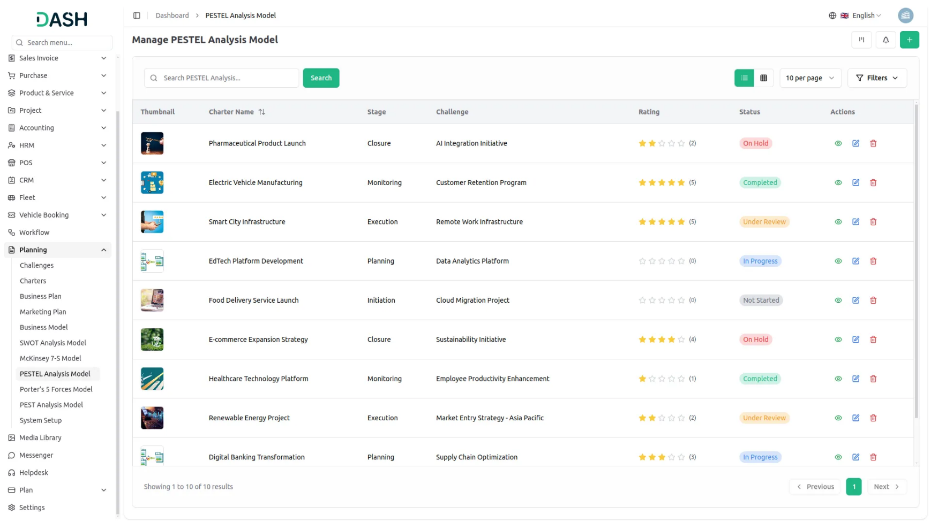

PESTEL Analysis Model Add-On, enabling businesses to strategically assess the external factors that influence their operations. With this model, you can evaluate key elements like Political, Economic, Social, Technological, Environmental, and Legal aspects, ensuring a comprehensive understanding of your market environment. The PESTEL Analysis Model can be customized and visualized in various formats, including grid view, kanban view, and tree view, providing flexibility to meet your business’s unique needs. Additionally, you can track progress, attach relevant documents, and make necessary revisions to align with evolving business strategies.
Dependency Notice: This Add-On depends on the Planning Add-On, so you must purchase and activate it first to access the PESTEL Analysis Model features.

Tech Trends Evaluation
PESTEL Analysis Model, businesses can now assess the technological landscape impacting their industry. This functionality allows users to evaluate technological trends, digital transformations, and emerging innovations. By analyzing technological factors alongside other key elements like Political, Economic, and Social influences, businesses can make informed decisions, enhance operational efficiency, and stay ahead of the competition in an ever-evolving digital world.
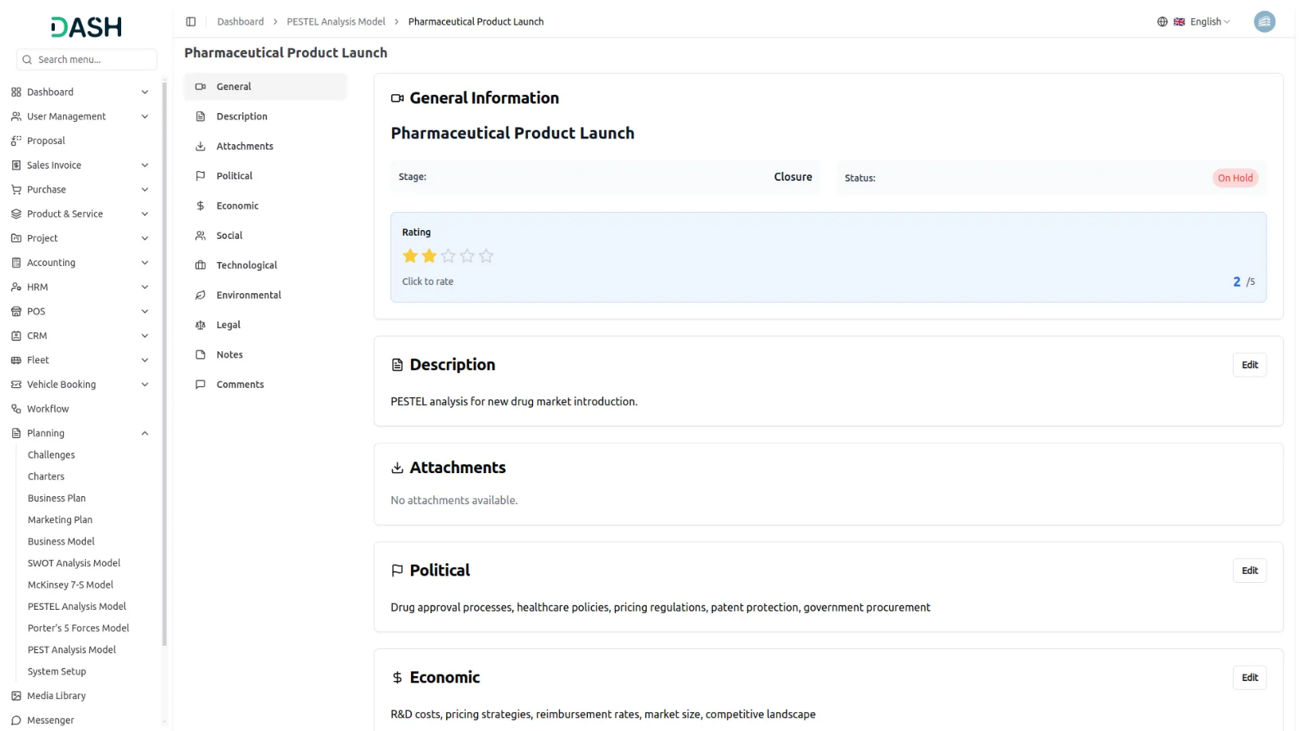
Political Analysis Grid View
With Grid View, the Regulatory & Geopolitical Insights section of the PESTEL Analysis model allows businesses to easily assess and monitor political and regulatory factors affecting their operations. The grid displays key details, including comments, attachments, challenge timelines, and assigned users, offering a clear, actionable overview. Users can seamlessly print, edit, or delete their analysis, ensuring they stay proactive and responsive to any regulatory or geopolitical changes.

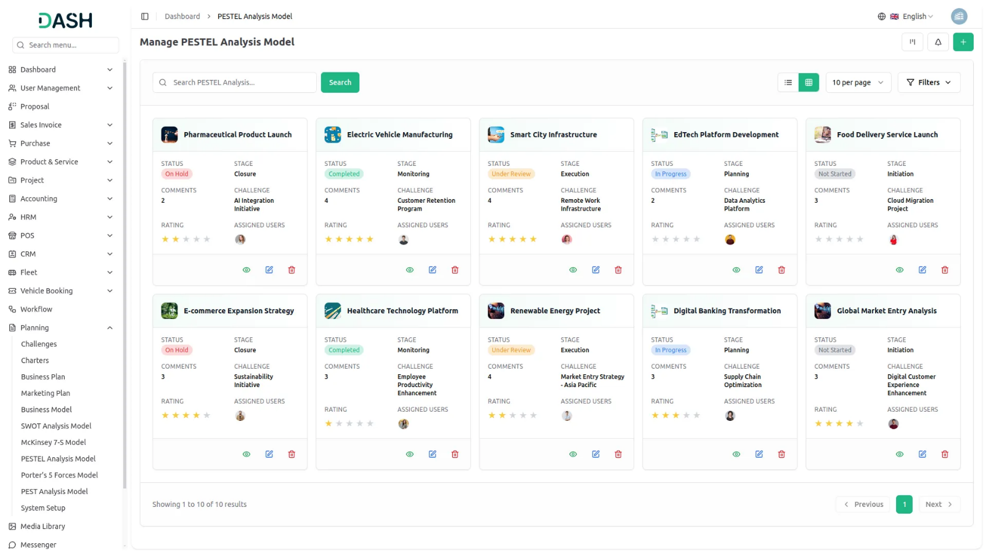
Economic Insights Kanban View
PESTEL analysis is showcased in a dynamic Kanban view. This feature allows businesses to evaluate and manage economic trends by organizing them into stages. With the ability to easily drag and drop PESTEL Analysis Models across stages, users can track the total number of models in each stage and make informed decisions on financial strategies. The Kanban view simplifies the process, making it easy to edit, print, and manage economic assessments for optimal business growth.
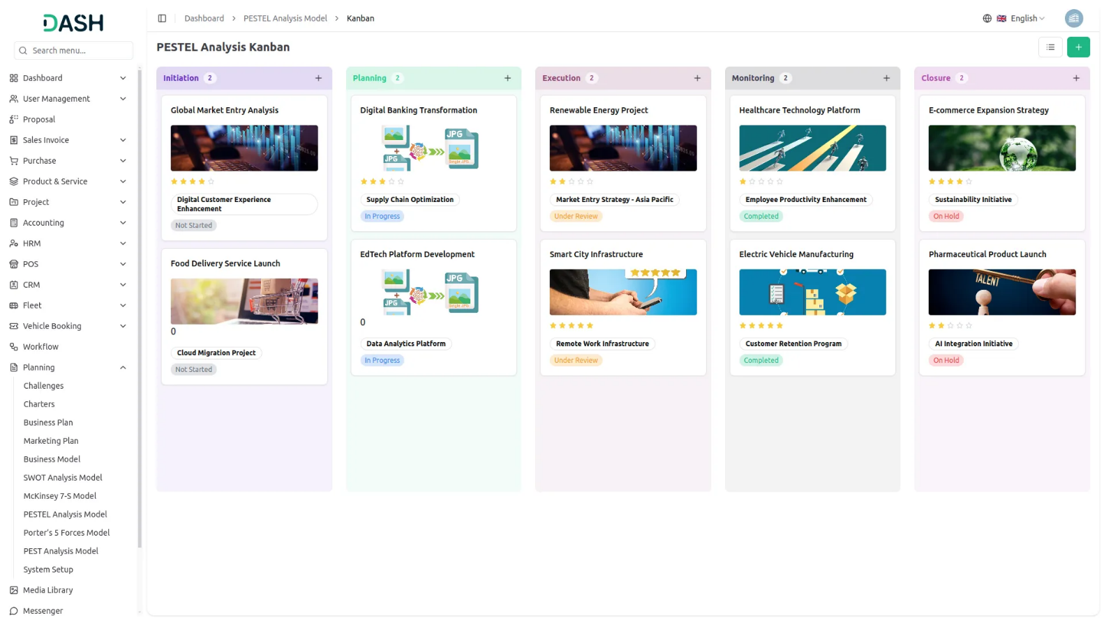

Social Insights Tree View
Presents a dynamic Social Factors analysis within the PESTEL framework, displayed through a tree view that adapts based on selected challenges. Users can easily choose challenges from a dropdown, and the relevant PESTEL Analysis Model will be shown in a tree structure. This feature allows businesses to assess societal trends, consumer behavior shifts, and demographic changes related to the selected challenges, providing clear insights to refine strategies and adapt effectively to the evolving social landscape.

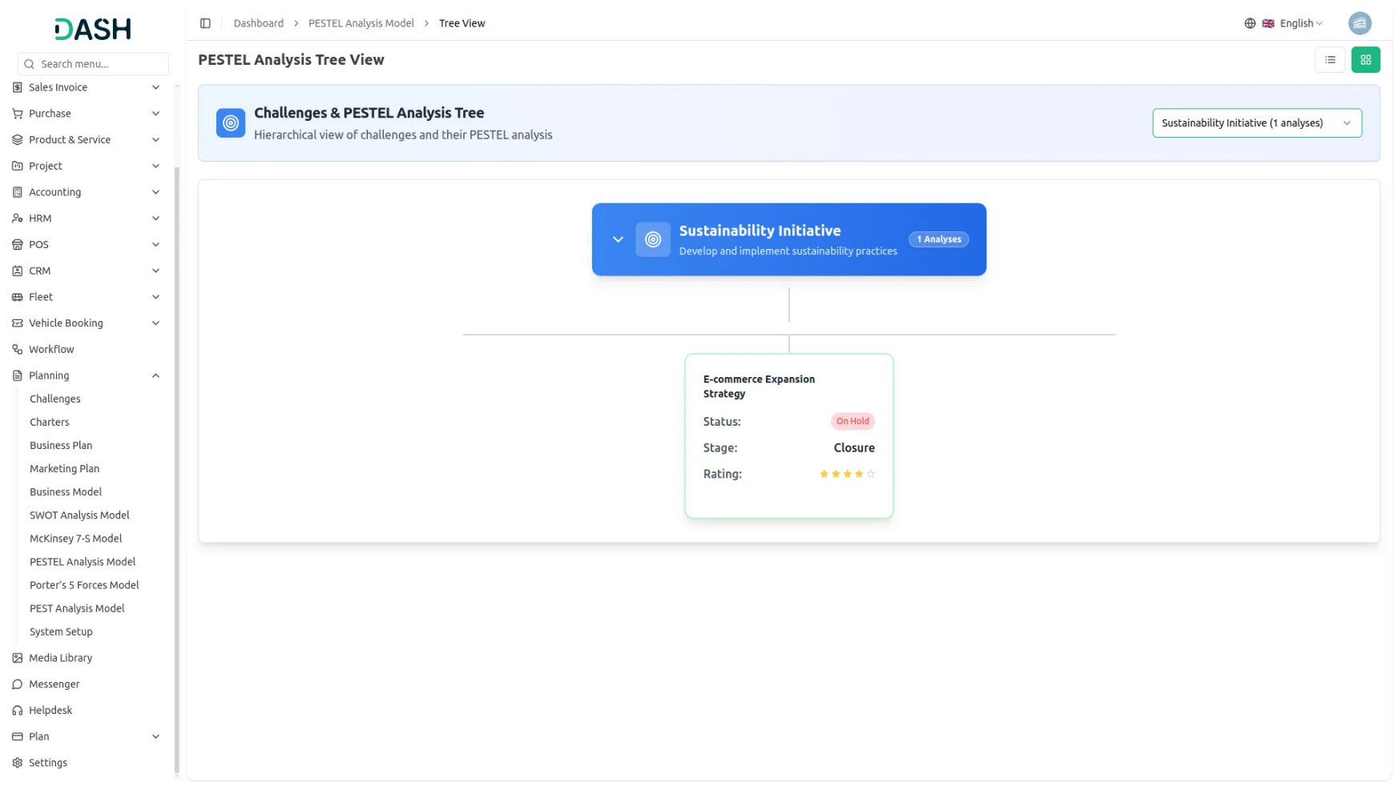

Introduction
The PESTEL Analysis Model is a strategic planning software tool that helps organizations analyze external factors that may impact their business. PESTEL stands for Political, Economic, Social, Technological, Environmental, and Legal factors. This module allows users to create comprehensive analysis models linked to specific challenges, assign them to team members with defined roles, and track their progress through different stages. The system provides multiple viewing options including grid, kanban, and tree structure views to help users organize and visualize their analysis work effectively.
Note: This Add-On is dependent on the Planning Add-On, so you need to purchase it first.
How to Use the PESTEL Analysis Model Add-On?
Managing PESTEL Analysis Model
- The default List View displays all PESTEL Analysis Models in a comprehensive table format with multiple management options. At the top of the page, you’ll find buttons for Create to add new analyses, plus three alternative viewing options for different management preferences.
- The main table presents detailed information with columns for Thumbnail Image providing visual identification, Name of the analysis model, Status fetched from System Setup showing current progress, Stage fetched from System Setup indicating analysis phase, Challenge fetched dynamically from Challenge Table showing associated business objectives, Rating for performance tracking, and Action column with management options.
- In the Action column, you have powerful options available: View to access complete analysis details and all strategic information, Edit to modify any aspect of the model including strategic assessments and team assignments, and Delete to remove analyses that are no longer relevant to your business strategy.

Creating PESTEL Analysis Model
- To create a new PESTEL Analysis Model, click the “Create” button at the top of the page. Start by entering the Name for your strategic analysis model, which should clearly identify the scope or focus of your external environment analysis.
- Select the Challenge from the dropdown menu, which fetches data from the Challenge Table. Important note: if the current date is greater than the Challenge End Date, you will not be able to create a PESTEL Analysis Model, ensuring all analyses remain aligned with active or future business challenges.
- Upload a Thumbnail Image to provide visual identification for your analysis model, and Upload Video content if you have supporting presentations or explanatory materials. Choose the appropriate Status from the dropdown menu, which fetches options from System Setup, and select the relevant Stage also fetched from System Setup to indicate the current phase of your analysis.
- Assign the Users involved in this strategic analysis by selecting from the Users dropdown, and choose the appropriate Role from the Roles dropdown to define team member responsibilities. Add a comprehensive Description that outlines the purpose and scope of your strategic analysis.
- Continue with the strategic analysis components by entering detailed information for Political factors, explaining how government policies, political stability, and regulatory changes may impact your organization. Document Economic factors by identifying economic conditions, market trends, and financial influences that could affect your business.
- Add comprehensive details for Social factors, outlining demographic changes, cultural trends, and social attitudes that could influence your organization. Complete the analysis by documenting Technological factors, identifying technological advances, innovation trends, and digital transformation impacts.
- Include detailed information for Legal factors, covering regulatory requirements, compliance issues, and legal changes that may affect your operations. Document Environmental factors, addressing sustainability concerns, climate change impacts, and environmental regulations.
- Include relevant Notes for additional observations, methodology details, or strategic insights, and attach supporting files through the Attachments field for research data, market reports, or reference materials. Once all fields are completed, click “Create” to save your PESTEL Analysis Model.

View PESTEL Analysis Model
- To view a PESTEL Analysis Model, click the “View” button in the Action column of any model in the list. This opens the PESTEL Analysis Model Details page with a comprehensive view of all information organized in expandable sections for easy navigation.
- The view page is structured with multiple collapsible sections starting with the General section which is expanded by default. The General section displays the model name, associated challenge, thumbnail image, uploaded video, current status fetched from System Setup, stage information, assigned users from the Users Table, and their designated roles from the Roles Table.Additionally, users can add a rating from this view page, and the same rating is also displayed on the index page.
- Click on the Description section to expand and read the complete purpose and scope of the strategic analysis as entered during creation. This section provides detailed context about the analysis objectives and methodology. An “Edit” button is available below this section to add new description content.
- The Attachments section can be expanded to access all supporting files including research data, market reports, reference materials, or any other documents uploaded during the model creation process. You can download or view these attachments directly from this section. Use the “Edit” button below to upload additional attachments.
- Expand the Political section to review all political factors, government policies, political stability considerations, and regulatory changes that may impact your organization. The Economic section shows all economic conditions, market trends, and financial influences that could affect your business operations. Click the “Edit” button below to include additional political factors.
- Click on the Social section to view demographic changes, cultural trends, and social attitudes that could influence your organization. The Technological section displays technological advances, innovation trends, and digital transformation impacts that may affect your business strategy. Use the “Edit” button to include new social considerations as societal trends evolve.
- The Legal section contains regulatory requirements, compliance issues, and legal changes that may affect your operations. Expand the Environmental section to review sustainability concerns, climate change impacts, and environmental regulations affecting your organization. Click the “Edit” button to include additional legal factors and regulatory updates.
- The Notes section contains additional observations, methodology details, strategic insights, or any supplementary information added during the analysis creation. This section provides context and additional commentary on the PESTEL analysis. Click the “Edit” button to include additional notes and observations.
- At last comes the Comment section from where you can post comments easily. You can also attach files in the comments section if you want.

Kanban View
- The Kanban View organizes PESTEL Analysis Models into columns based on their current stage, providing a workflow-based visualization with drag and drop functionality. You can easily move models between different stages by dragging cards from one column to another.
- Each Kanban card shows essential information including the total number of assigned users.
- The drag and drop functionality allows you to update the stage of any PESTEL Analysis Model by simply moving it to the appropriate column. Action buttons on each card include View for detailed information, Edit for modifications, and Delete for removal. This view is ideal for tracking the progress of multiple analyses through different stages of completion.

Tree View
- To switch to Tree View, click the “Tree View” button at the top of the page. This view presents a hierarchical structure that displays challenges and their associated PESTEL Analysis Model in an expandable tree format, showing the parent-child relationships clearly.
- The Tree View includes expand/collapse functionality, indicated by the arrow icon next to each challenge name. Clicking the arrow allows you to expand the challenge to reveal its associated models or collapse it to show only the challenge title, making navigation more organized and focused.
- In the Tree view, each challenge appears as a blue header bar with the number of plans indicated. When expanded, it displays the associated models beneath it in card format, showing key details including the model name, status, stage, and rating displayed as stars.

